Acceleration - Ticker Tape Experiment
Review: 1. What is the formula for speed?
2. What is a vector?
3. What are the units of speed?
Learning Objectives
- Recall and use the formula for acceleration
- Learn the use of ticker tape for measuring speed and acceleration
- Find a value for the acceleration of free fall on earth
Page ref New Hodder Book P 8-10. But better spread on P 30-31 in Old blue Oxford Book if access is available.
Practice Question:
Q1. A car drives down the road at 12m/s. It accelerates to 24m/s over 15 seconds.
Calculate its acceleration.


Q2. A train accelerated at 1.2 m/s² from an initial speed of 10m/s to 45m/s. Calculate the time taken. .

Research question
What is the acceleration due to gravity as calculated by using the ticker tape timer?
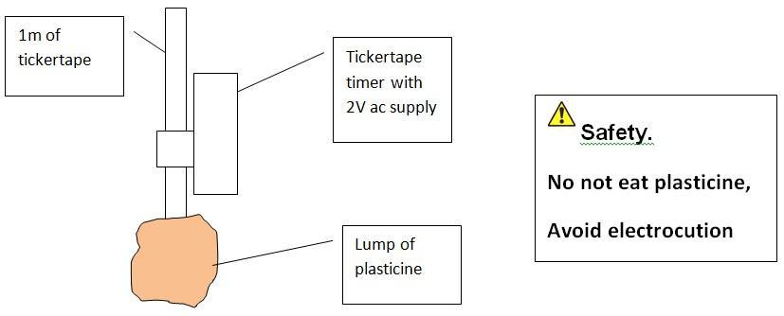
Method
- Set the powerpack to 2V a.c.
- Allow the plasticine to fall whilst dragging ticker tape through the timer.
- Choose two places along the ticker tape that are 10 dots apart.
- Calculate the speed at start by measuring the distance between two consecutive dots.
- Calculate the speed at end by measuring the distance between two consecutive dots
- Calculate the acceleration of gravity.
Have a look at this youtube video to get an idea: https://www.youtube.com/watch?v=FcvW7PxqgTo
Also look at book page 30 to 31 and answer the questions.(No 1)
Calculations
The speed calculation is quite easy:
Speed = Distance / time
The unit of speed is m/s
The timer makes 50 dots in one second. Time between dots is 1/50 = 0.02s
The acceleration calculation is quite easy:
Acceleration = change in .......... / time
The unit of acceleration is m/s²

(No 2)
Example:
d_{o} = 1.3cm Initial speed = dist / time = …............ / 0.02 = ….............… m/s
d₁₀ = 5.3cm Final speed = dist / time = …..........… / ……...... = …...........…. m/s

Acceleration = (V – U )/t = ( …..........…. - ….........…. ) / 0.2 = …...................…. m/s²
The accepted value for the acceleration due to gravity is ...... m/s²
Account for the difference in your value:
……………………………………………………………………………………………………………………………………………….

Practice Questions:
1. A train decelerates at a constant rate in a straight line. The velocity of the train decreases from 50 m/s to 42 m/s in 30 seconds.
(a) Calculate the change in velocity of the train.
(b) Calculate the deceleration of the train, and explain how your answer shows the train is slowing down.

2. A stone is dropped from a cliff. What is its speed 2 seconds after?

Demonstration
What is the relationship between the height of a ramp and the acceleration of a trolley down the ramp?
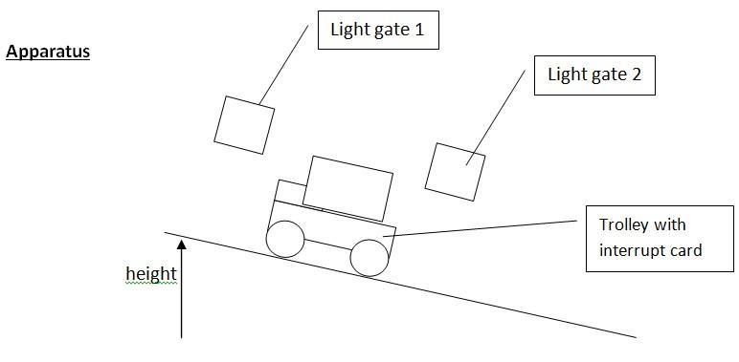
Method
- Set the ramp to a chosen height and ensure the light gates are at a correct height.
- Allow the trolley to accelerate down the ramp.
- Record data from the computer for the speed at the first and second light gate and also the time interval.
- Calculate the acceleration.
- Repeat the process and gain an average acceleration.
- Continue for seven different heights of the ramp.
- Plot a graph of Height (x-axis) against Acceleration (y-axis).

We can’t do this but here is a video that shows how light gates work:
https://www.youtube.com/watch?v=xdKufK65byM
Now and for Homework:
Finish the graph
P9 Q1 &2 in New Hodder Book
P31 Q1-3 in Old Blue Oxford Book

